In which journal should I publish

By Simon Moss

# Introduction

Either during or after your course, you are likely to submit one or more papers to a journal. To choose the right journal, you should

* identify 4 to 10 journals in which your research is likely to be relevant
* omit journals that are predatory or vanity publishers
* omit journals in which your paper does not conform to the instructions
* submit in order of quality

# Step 1 Identify 4 to 10 journals in which your research is likely to be relevant

Initially, you should identify a preliminary set of journals you might consider. To achieve this goal, you can obviously seek advice from supervisors or peers. In addition, you can skim your reference list to identify journals that you cited.

**Journal finder**

You might want to utilize programs, such as the Elsevier Journal Finder, to identify possible journals. In particular

* proceed to https://journalfinder.elsevier.com.
* simply copy your title and abstract in relevant spaces. You can also indicate the relevant field, such as social sciences or life and health sciences
* print or copy the results of this search
* an example of the output appears below

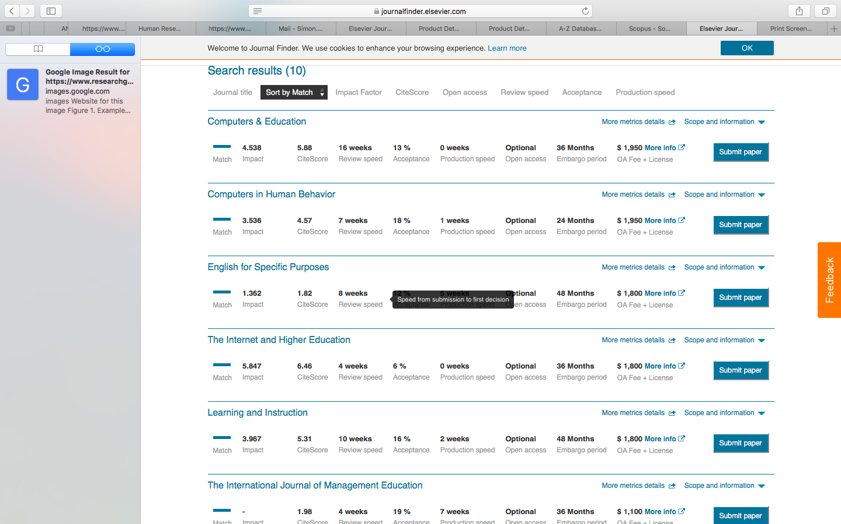

**SCIMAGO: To identify Q1 journals**

One drawback of Journal Finder is this database will not limit your search to Q1 journals. Specifically, like most universities, CDU prefer that you publish your work in Q1 journals only, at least whenever possible. Q1 journals are the top 25% of outlets in each field and tend to attract the most citations and respect. To locate potential Q1 journals, you should use SCIMAGO instead of journal finder. In particular

* visit www.scimagojr.com/journalrank.php
* choose a relevant option from All subject areas or All subject categories—such as Accounting—to generate a list that resembles the following display
* then, peruse the list to identify potential journals that could be relevant. But, direct your attention only to Q1 journals—as signified by the green Q1 symbol

# Step 2 Omit journals that are predatory or vanity publications

The previous phase is likely to uncover only reputable journals. Nevertheless, if you are not familiar with these journals, you should assess whether they are vanity and predatory publications. Vanity and predatory publications do not actually peer-review the paper—although they might assert and pretend otherwise. Consequently, these publications are not perceived as legitimate. Typically

* vanity publications charge authors to publish their paper or book—but without the provision of editorial or publishing services. In contrast, legitimate journals either do not charge authors or charge authors in accord with the services they offer, such as open access or coloured figures.
* predatory publications are similar, but often charge to enable authors to publish open access—that is, so anyone can read the publication at no cost.

To ensure the journal is not a vanity or predatory publication, you could

* visit https://beallslist.weebly.com/standalone-journals.html. Journals that appear in this list are predatory and should be discarded
* avoid journals or books published by LAPLambert, VDM, or Nova Science. These publishers often publish work that is not peer-reviewed.

In addition, you can assess whether or not the journal is recognized by ERA or Excellence in Research for Australia. Journals that are recognized by ERA will not be vanity publications, predatory publications, or unreputable publications. To achieve this goal,

* visit <http://lamp.infosys.deakin.edu.au/era/?page=jnamesel15>
* enter the journal name in the leftmost box and press Search

# Step 3 Omit journals in which your paper does not fulfill the criterion for submission

After completing the previous phase, you might have identified three to ten journals to which you could submit. On the website of each journal are instructions that specify the criteria that submissions must fulfill. To assess whether your paper fulfills these criteria

* google, and then visit the website, of each journal
* if possible, locate a link to “instructions for authors”, “author guidelines”, “submission guidelines”, or something similar

If you are too busy to read all the instructions, focus your attention on

* whether your publication matches the aims or scope of this journal.
* the minimum and maximum length of papers
* whether the editors prefer empirical papers, systematic reviews, or other kinds of papers
* whether the editors prefer quantitative papers, qualitative papers, or both
* which disciplines the editors prefer
* the costs to authors if the paper is accepted

If you are not sure whether your paper fulfills these criteria, you could email the editor. A sample email appears below.

|  |
| --- |
| Dear Professor Smith  I would like to submit a paper, entitled “Animals and academics”, to the Journal of Zoos. This paper outlines an observation study on the similarities between animals and academics. We applied a blend of thematic analysis and word count methods to analyze the data.  However, we are not certain whether this topic is germane to this journal. In addition, the paper is two pages longer than is the recommended maximum. Would you be able to advise us on you believe we should this manuscript to this journal?  Yours sincerely  Matt Matts |

# Step 4 Omit journals that do not permit you to include your article in your thesis

If you want to include this article in your thesis—often called thesis by publication—you should check the restrictions this journal imposes on authors. The vast majority of reputable journals will permit you to include this article in your thesis. Nevetheless, to check

* on the webpages of most journals is a link to a copyright, author, or contributor agreement.
* if you can locate this agreement, check whether the publisher has explicitly permitted authors to use their work in theses or dissertations
* if unsure, in the contacts list, identify the most suitable person to contact, and write the following

|  |
| --- |
| Subject: Clarifying whether I am permitted to include my work in a thesis by publication  Dear …  I am completing a PhD at Charles Darwin University. I am planning to submit a manuscript entitled “….” to your journal. I am enquiring as to whether I can include this paper, for an indefinite period, in an electronic version of my thesis—a thesis that would be stored in an open access digital archive at my university.  Kind Regards… |

If you later discover that you are not permitted to include work you have already published in your thesis, seek an exception. That is, in the contacts list, identify the most suitable person to contact, and write the following:

|  |
| --- |
| Subject: Clarifying whether I am permitted to include my work in a thesis by publication  Subject: Seeking permission to include my work in a thesis by publication  Dear …  I am completing a PhD at Charles Darwin University. My research thesis includes the paper entitled “….” that was published in this journal. I am enquiring as to whether I can include this paper, for an indefinite period, in an electronic version of my thesis—a thesis that would be stored in an open access digital archive at my university.  Otherwise, I would like to seek from you a limited, non-exclusive license, to include this work in an electronic version of my thesis. If you agree to this license, could you notify me in writing  Kind Regards |

# Step 5 Omit journals that you cannot afford

Some prestigious journals are open access. That is, people can access the papers without needing to subscribe or paper. The benefit is that more people will read, and ultimately cite, these papers. The drawback is that, to publish in the journal, authors must pay a fee—a fee that can exceed $2000. To pay this fee, you could

* use your own money; thus option is seldom necessary
* use your research allocation; although you might want to reserve this money to purchase services or products that are vital to your research
* ask your college to pay this fee; the college may pay in particular circumstances

**University support**

Fortunately, in specific circumstances, Charles Darwin University will pay up to $2500 US if you publish in a prestigious journal. Specifically, you need to publish in Q1 journals. To ascertain whether or not a journal if Q1

* proceed to <https://www.scimagojr.com>
* enter the name of this journal in the search box
* if several options appear, click the relevant journal
* in the output, scroll down to locate a display called “Quartiles”.
* the green colour indicates Q1
* if the journal if Q1, contact a research administrator or research academic in your college—such as a HDR convenor or Assistant Dean of Research—to request this payment.

# Step 6 Rank the possible journals from most appropriate to least appropriate

After completing the previous phase, you might have identified two to five journals to which you could submit. Your final task is to rank these journals from most appropriate to least appropriate. To complete this task, perhaps rate each journal on three attributes: impact factor, acceptance rate, and relevance. The following table presents an example. To gauge impact factor—the average number of times each paper is cited every year

* Google the website of this journal; or you may have uncovered this information from the Elsevier Journal Finder
* Alternatively, you can utilize other measures of quality or citation rate.
* For example, access Scopus—available from the CDU library databases or http://libguides.cdu.edu.au/az.php. Choose “Sources” at the top , click the orange box to choose “Title”, and then enter a journal in the adjacent box.
* This procedure will generate a series of indices—such as CiteScore.
* CiteScore, when divided by 3, is comparable to impact factors.

To gauge the acceptance rate

* Google the name of this journal and “acceptance rate”
* Or you may have already uncovered this information from the Elsevier Journal Finder
* You could also email the editor to seek this information
* Alternatively, assume the acceptance rate is around 15%, unless other people indicate the acceptance rate is higher or lower than average.

|  |  |
| --- | --- |
| A picture containing indoor, sitting, table, holding  Description automatically generated  Did you know | According to some authors, journals that are designed to be more applied and practical rather than theoretical tend to accept a higher percentage of papers (Nguyen & Renandya, 2020) |

Next on a scale from 1 to 5, estimate the relevance of this journal. Finally, sum the columns to generate a total score for each journal.

|  |  |  |  |  |
| --- | --- | --- | --- | --- |
| Journal | Impact factor or similar | Acceptance rate | Relevance to topic | Total |
|  | 1: 0 to 1  2: 1 to 2  3: 2 to 3  4: 3 to 4  5: 4 + | 1: 0 to 5%  2: 5 to 10%  3: 10 to 20%  4: 20 to 30%  5: 30+ | 1 Very broad scope  5: Topic specific to paper |  |
| Computers and Education | 5 | 2 | 5 | 12 |
| Learning and Instruction | 4 | 2 | 5 | 11 |
| Computers in Human Behavior | 4 | 2 | 3 | 9 |
| Journal of School Psychology | 3 | 2 | 1 | 6 |

# Step 7 Submit the paper

You should usually

• submit the paper to the journal that receives the highest total

• if this journal rejects the paper, attempt the next journal, and so forth

# References

Nguyen, M. T. T., & Renandya, W. A. (2020). Growing our research impact. In Professionalizing Your English Language Teaching (pp. 337-347). Springer, Cham.

**WORKING PAPERS**

**Alternatives to Q1 papers**

Not all of your papers will be publishable in Q1 journals. For example

* pilot or preliminary studies are seldom accepted in Q1, or even Q2, publications
* studies in which the results were not significant are seldom accepted in Q1 or Q2 publications
* studies in which the methods were compromised—such as inadequate sample sizes—are seldom accepted in Q1 or Q2 publications

In these circumstances, you should consider one of three options. The first column in the following table outlines these options. The second column stipulates the drawbacks of each option.

|  |  |
| --- | --- |
| Option | Drawbacks of this option |
| Include this work in an unpublished chapter of your thesis | * Skim [this document](https://www.cdu.edu.au/files/2020-07/Should%20I%20write%20the%20thesis%20by%20publication.docx) especially the section labelled “Drawbacks of thesis by publication” |
| Publish in a Q2, Q3, or Q4 journal | * Universities usually prefer that candidates publish only in Q1 publications or occasionally in Q2 publications * So, if your track record comprises several Q2, Q3, and Q4 publications, you might be less able to secure roles in research than if your track record comprises only one or two Q1 publications |
| Publish a working paper | * Working papers are not deemed as peer-reviewed articles |

A working paper is merely a paper that you upload on the web, enabling other people to access this work. Working papers, although not peer-reviewed articles, can significantly benefit your career. The following table outlines the benefits of working papers.

|  |
| --- |
| Benefits of working papers |
| **Motivation.** Candidates often feel more inspired to write working papers than standard chapters. A working paper is a more tangible, immediate, and thus inspiring goal |
| **Track record**. Although not as respected as peer-reviewed articles, working papers can still be listed on your CV and, therefore, improve your track record more than standard chapters |
| **Collaborations**. Working papers can help you develop networks and develop collaborations. The working paper can appear on a site that potential collaborators, partners, or employers can access. In addition, you can distribute the working paper to these individuals as well |

**Where to upload working papers**

You can upload working papers on a variety of sites. One example is the repository of research projects and publications in CDU, called the CDU Research Web Portal. If you upload your working paper onto this website

* other individuals and organizations will be able to access this work
* in the future, CDU may attempt to promote your work, and other working papers, to potential industry partners.

**How to upload working papers**

To upload working papers to this CDU Research Web Portal, you merely need to

* visit the web portal—that is, <https://portal.cdu.edu.au/>
* choose the tile called RIS, an abbreviation of Research Information System
* a database, called Pure, should then appear—an extract of which appears in the following display

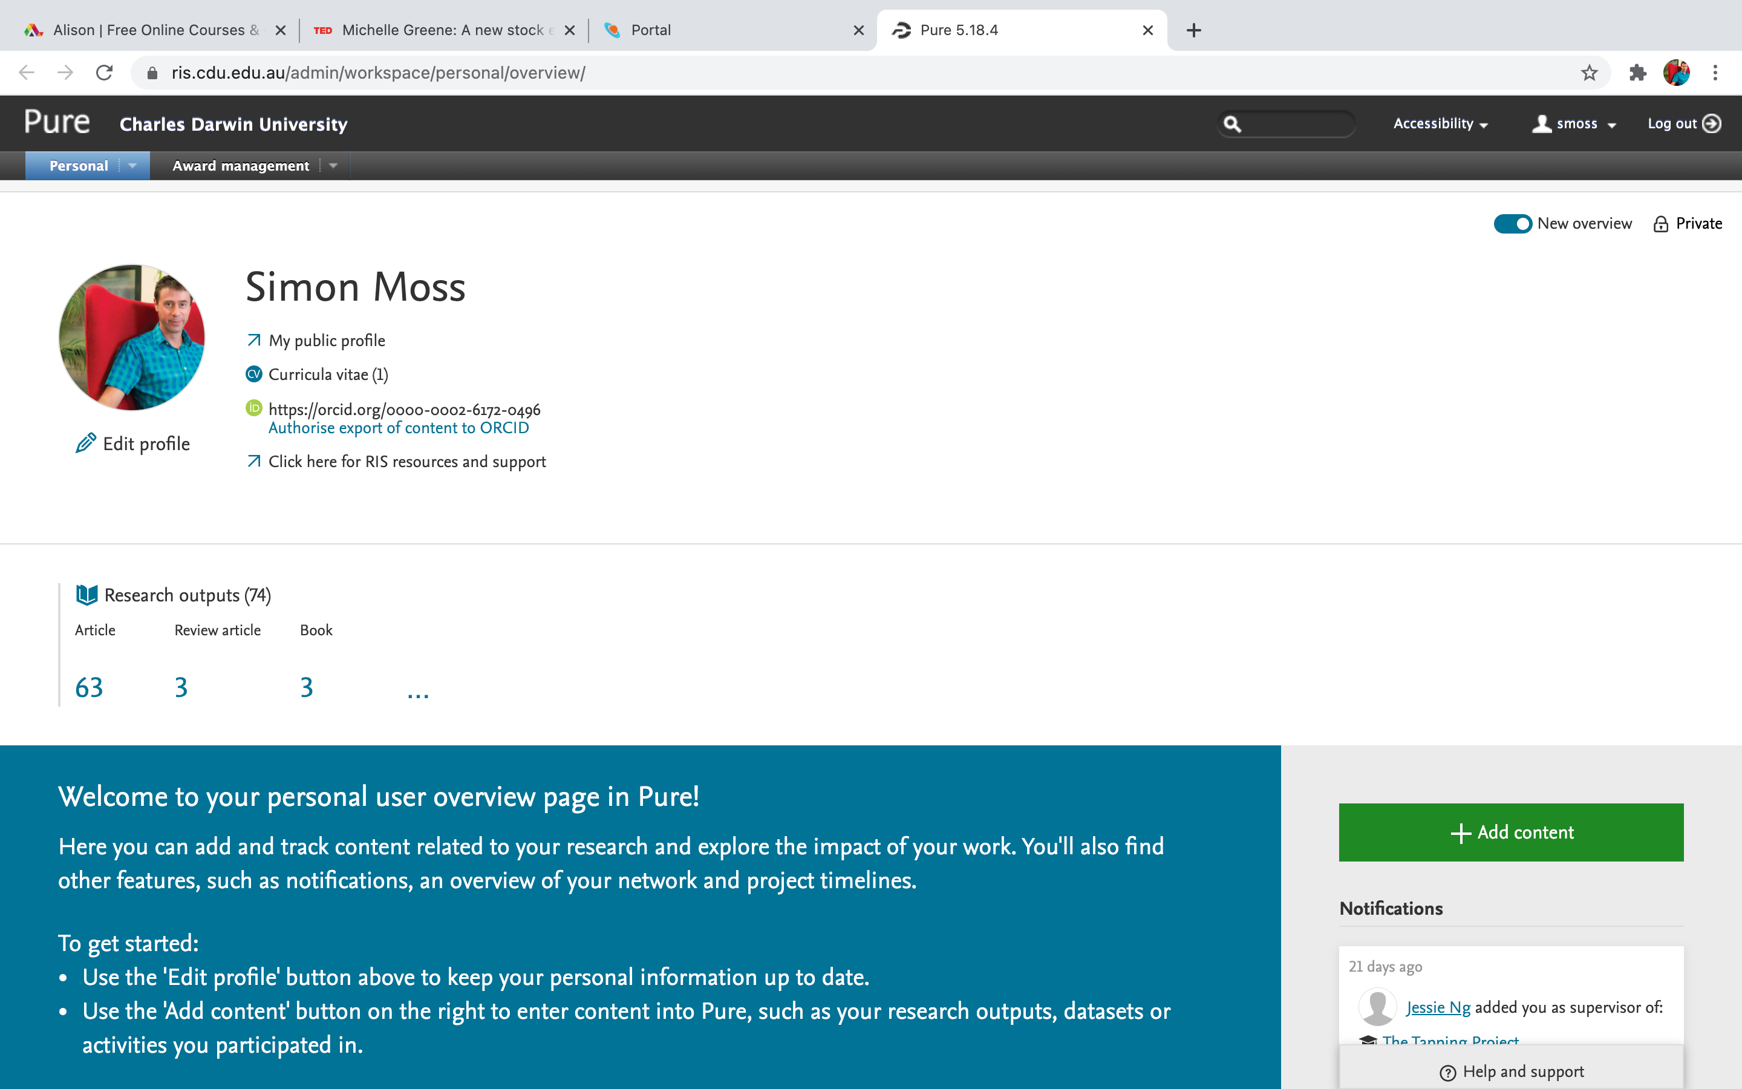

After you press the downward arrow next to “Personal”, something like the following display should appear.



Once this display appears,

* click “New” under “Research outputs”—as indicated by yellow circle in the previous display
* choose “Working paper” from the list of options that appear—and then “working paper” again to generate the final box of options. An extract of this box appears in the following display

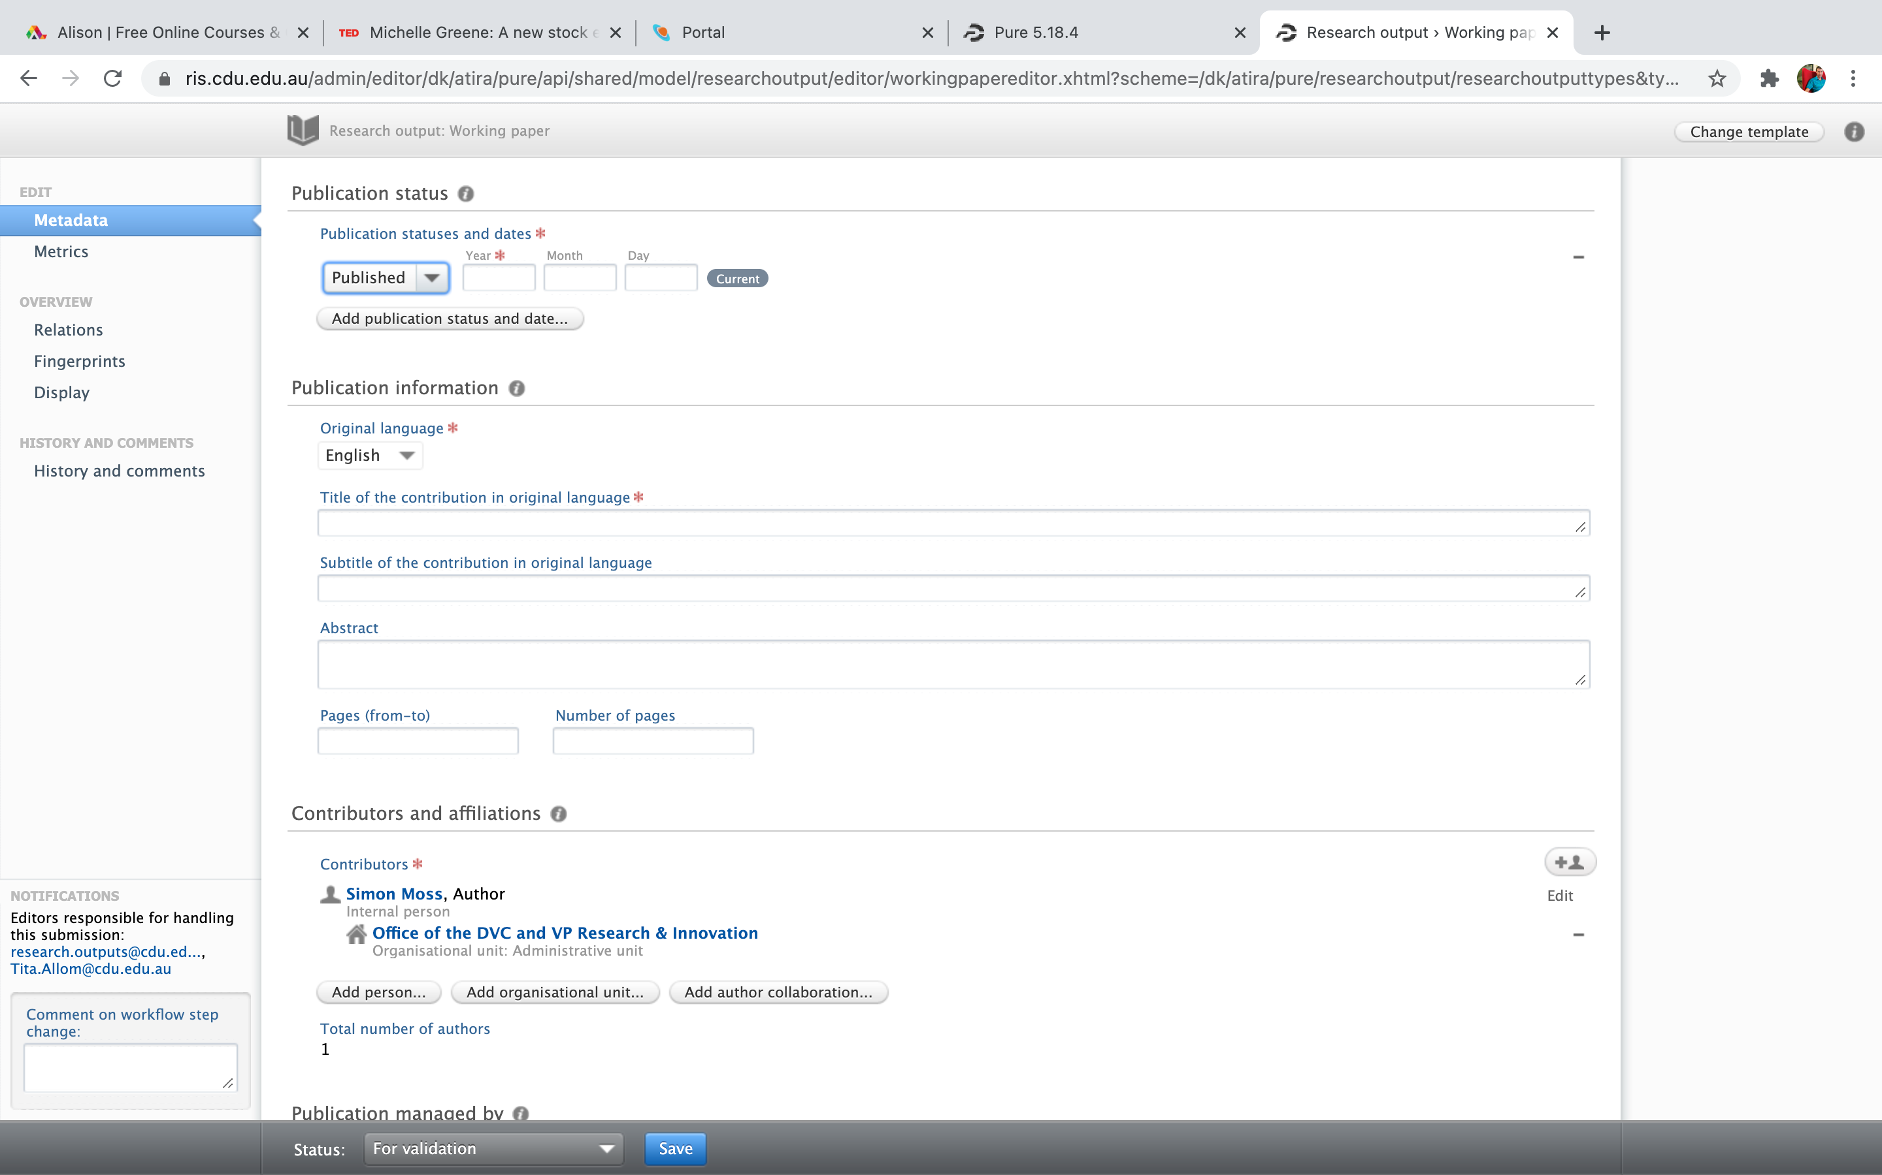

Initially, this box seems overwhelming. But, you do not need to complete all the information. Your main task is to

* under the heading **publication status**, enter the date and indicate the paper is unpublished
* under the heading **publication information,** enter the title and perhaps an abstract or summary
* under the heading **contributors and affiliations**, add other co-authors, if applicable
* most importantly, under the heading **Electronic versions and related files and links**—further down in the box—press “add electronic version” to upload the file.
* under the heading **keywords**, enter some relevant terms
* consider some other information you could include as well
* press “save” on the bottom.

**Working papers in your thesis**

Working papers can be treated like a typical publication in your thesis. For example, in one of the preliminary papers of your thesis, when you list the publications this thesis entails, you can include these working papers. You might write something like

* Moss, S. A. (2022). How to inspire research candidates. CDU Working Paper Series. Available at <http://cdu.edu.au/abstract=202>.